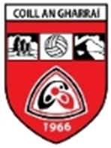 | KILLYGARRY GAA CLUB | 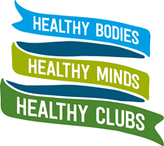
Health & Wellbeing Statement
Killygarry GAA believe that we need to work towards creating a healthy club environment that is inviting to all and which promotes the integration of healthy behaviours into the everyday activities of the club. We are committed to promoting health and well-being amongst our members and the wider community.
The aim of this policy is to help make our club a healthier place for all members to enjoy.
Our club will hold health and wellbeing as a core value – it is everyone’s responsibility and we all play a part.
Our club is the healthy heartbeat of our community.
Our club will do what we already do, only healthier.
Our club will facilitate healthy participation in our games.
Our club acknowledges that it has a role to play in supporting the physical, mental and social health of our members.
Our club will help to make the healthy choice the easy choice.
Our club will leave a legacy that enhances the health of the next generation.
Our club is an inclusive club. We develop people not just players.
Our club is an age-friendly club. We will strive to cater for our members throughout their lifespan.
Our club will engage with the wider community to build a stronger community.
Our club will empower our members to enjoy healthier lives.
We are a community club, not just a sports club. Our club is committed to promoting health and well-being amongst our members and the wider community.
Signed:
Chairman Killygarry GAA Club
Date:

